XWM Webserver

UPTO

Contents

XWM Webserver 3

Install Ubuntu 3

Create the virtual machine ‘xwm-web’ 3

Name and operating system 3

Memory size 3

Hard disk 4

Hard disk file type 4

Storage on physical hard disk 4

File location and size 5

Install Ubuntu 6

Configure ‘xwm-mysql’ to boot from the installation image 6

Create a Virtual Box snapshot 8

Bridge the network connection 9

Install deja-dup and do a backup 10

Remote desktop using xRDP 12

Configure the firewall for RDP 12

Remote onto xwm-mysql 13

Install Apache 14

Overview 14

Install Apache 14

Setting Up Virtual Hosts 15

Test the site 18

Install Visual Studio code 20

Install MySQL 21

Install MySQL on xwm-web 21

Connect to a remote MySQL server 22

# XWM Webserver

Create a webserver xwm-web that:

* allows users to update settings
* responds to REST commands sent from the mobile app TUFCv3
* sends SQL queries to the database xwm-mysql

# Install Ubuntu

## Create the virtual machine ‘xwm-web’

To create a new Virtual Machine in Virtual Box

select: Machine > New

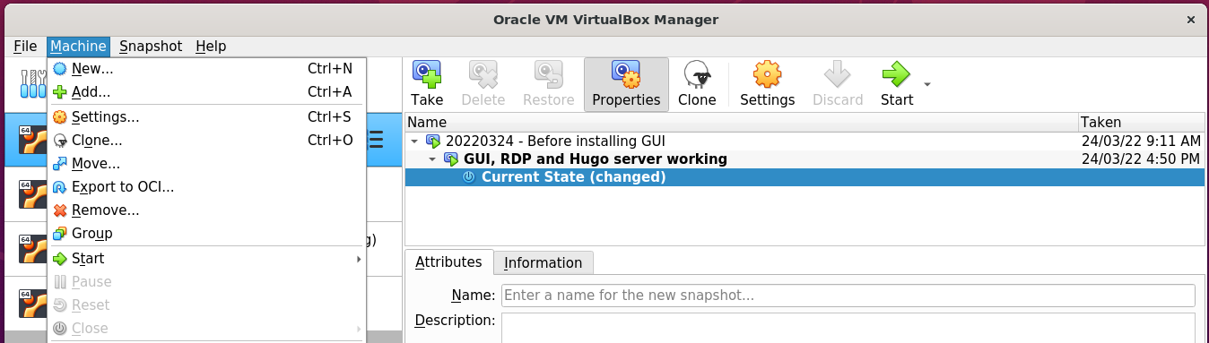

### Name and operating system

Name: xwm-web

Folder: /media/nath/4TB/XWM

Type: Linux

Version: Ubuntu (64-bit)

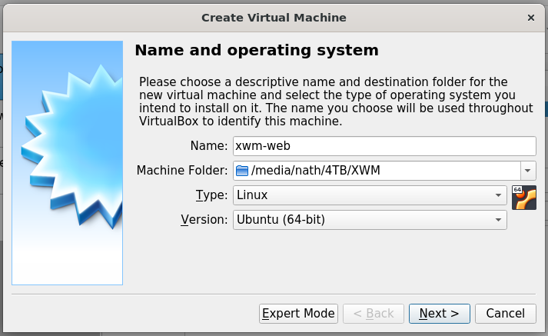

### Memory size

Select: 4096 MB

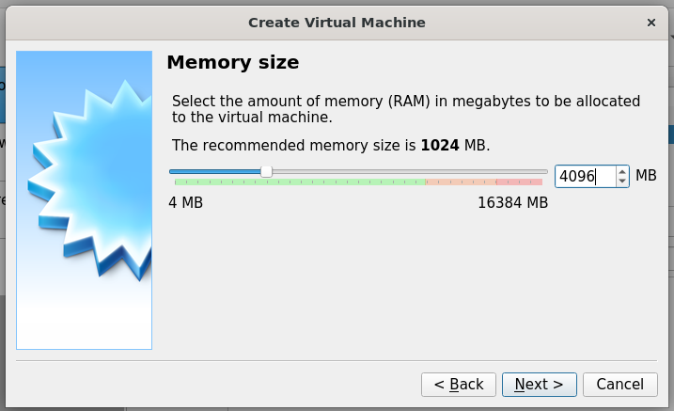

*Next, Hard disk …*

### Hard disk

Select: Create a hard disk now

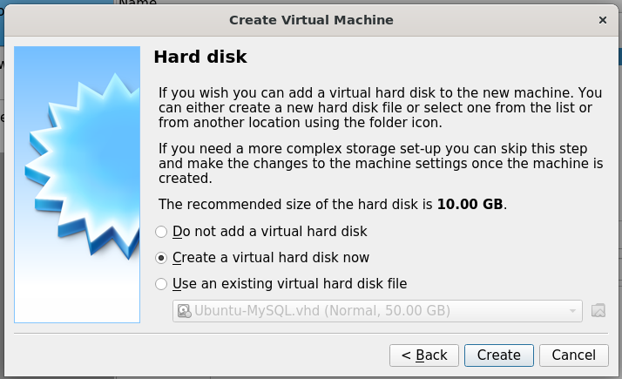

### Hard disk file type

Select: VHD (Virtual Hard Disk)

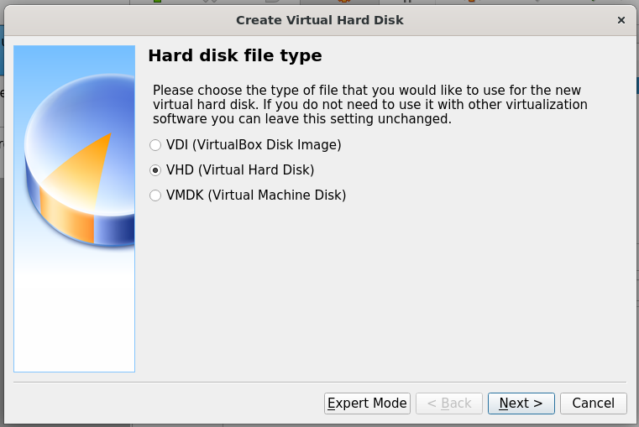

### Storage on physical hard disk

Select: Dynamically allocated

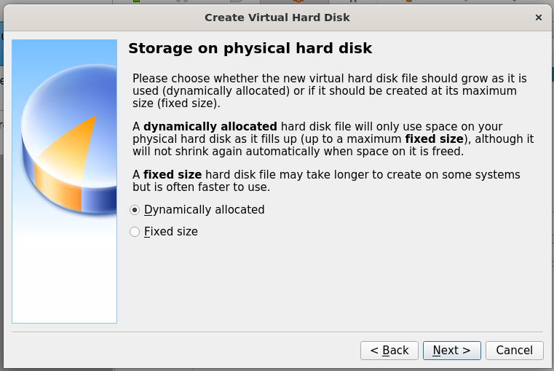

*Next, File location and size …*

### File location and size

Location: /media/nath/4TB/XWM/xwm-mysql/xwm-mysql.vhd

Size: 50 GB

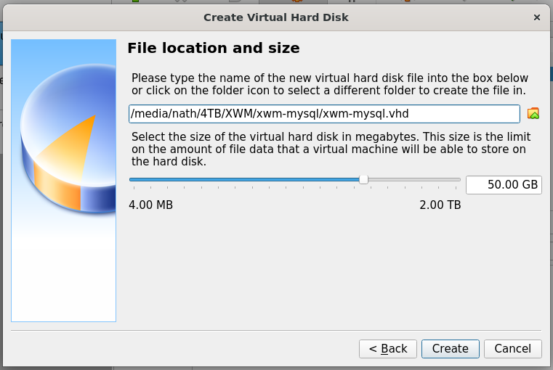

Click: Create *(above)*

The virtual machine xwm-web

is displayed in the left column Virtual Box.

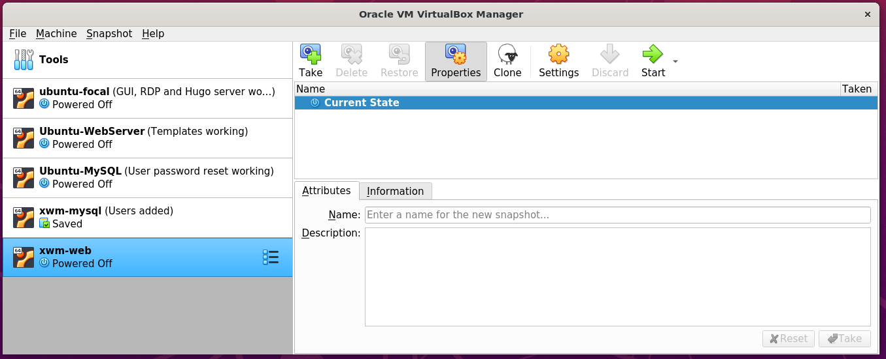

*Next, Install Ubuntu …*

# Install Ubuntu

Download the latest version of Ubuntu from: https://ubuntu.com/download/desktop

### Configure ‘xwm-mysql’ to boot from the installation image

Open Virtual Box on the host server Ubuntu-LAMP

In the left column, right click the virtual machine xwm-web

and select Settings

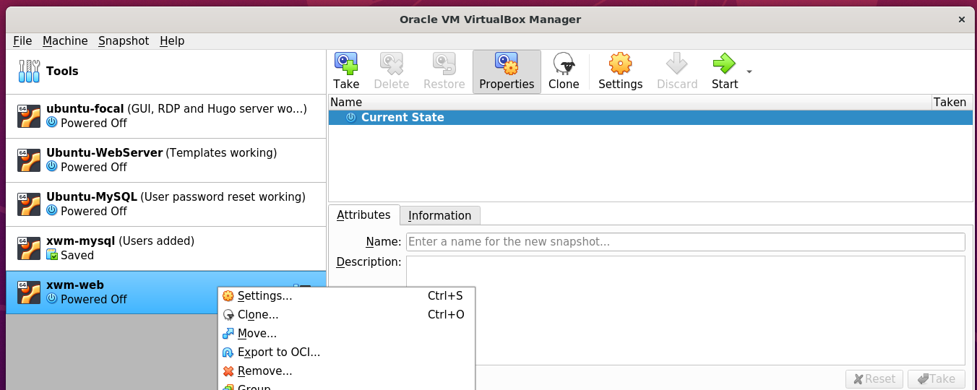

In the left column of Settings, select Storage

then in the middle panel, select Controller: IDE

on the right, select Choose a disk file

and select the downloaded Ubuntu installation image.

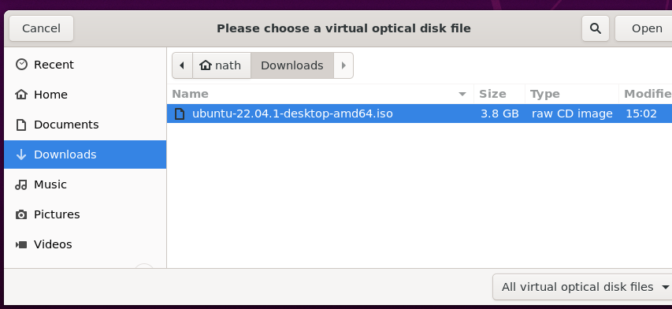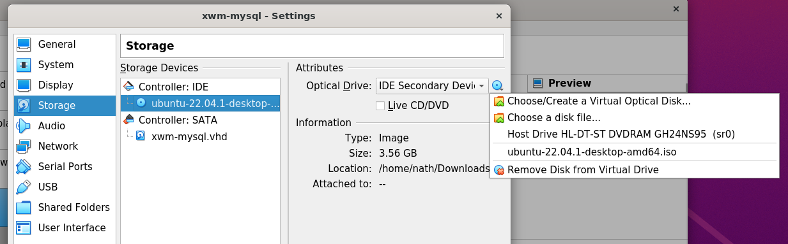

The installation iso has been selected

as the virtual machine’s CD

This means that when xwm-web boots

it will run the installation iso image.

Start the virtual machine xwm-web

by clicking Start > Normal Start

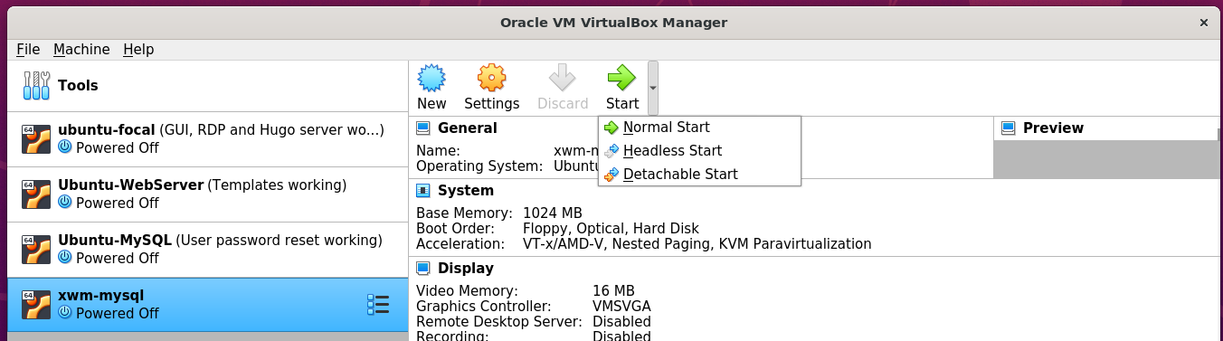

The boot options are displayed.

Select: Try or install Ubuntu

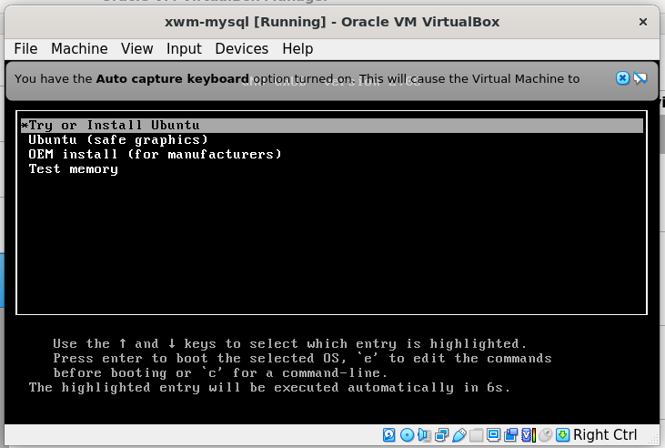

Follow the installation prompts to install Ubuntu

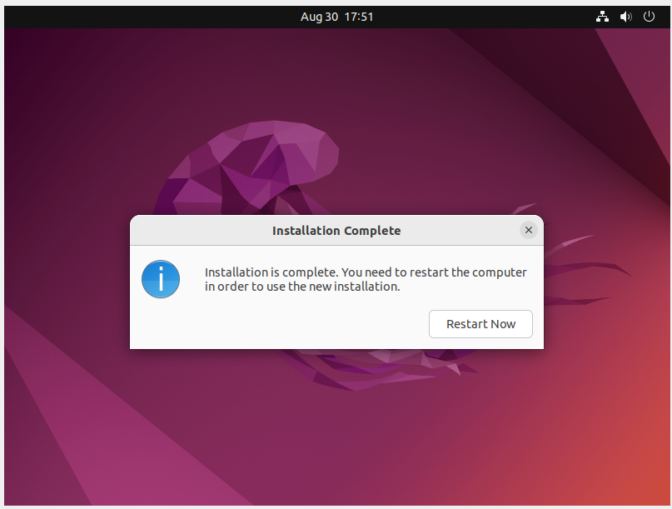

Shut down xwm-web

remove the installation iso

then restart the virtual machine

to complete the installation.

*Next, create a snapshot …*

## Create a Virtual Box snapshot

Once the installation completes

restart the virtual machine

run Ubuntu updates

then create a snapshot of xwm-web

Create a snapshot

of the newly installed virtual machine xwm-web

In the left menu of Virtual Box

click xwm-web’s settings icon *(the waffle)*

and click Snapshots

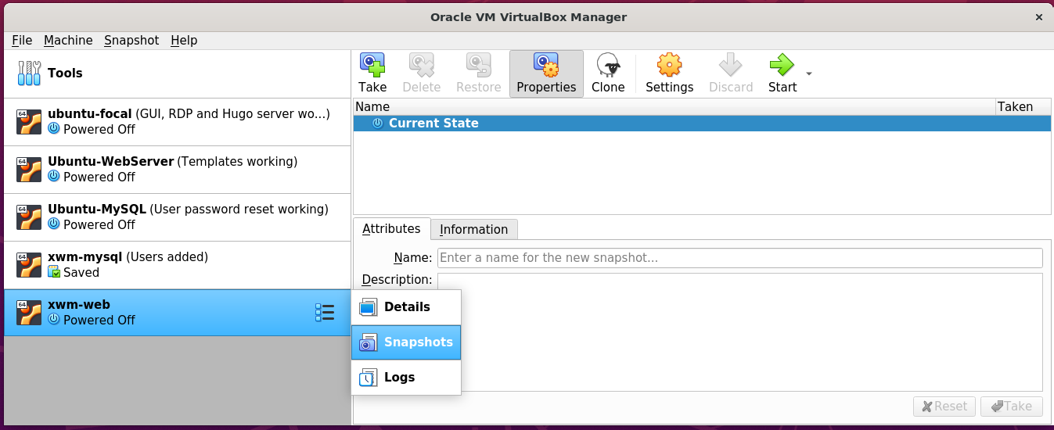

Then on the right, click the Take icon.

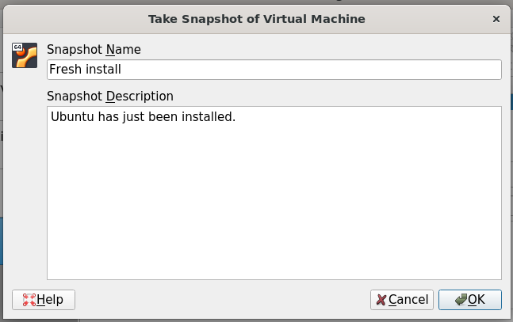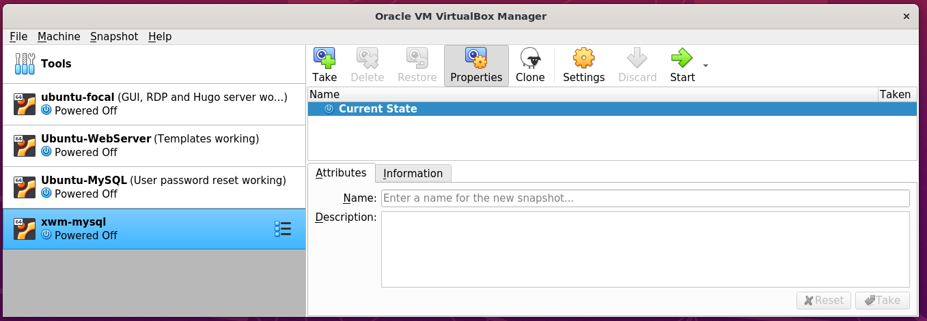

## Bridge the network connection

xwm-web is currently on it’s on virtual network.

To allow it to communicate with other devices on the network

right click xwm-web from Virtual Box’s left menu

and select settings

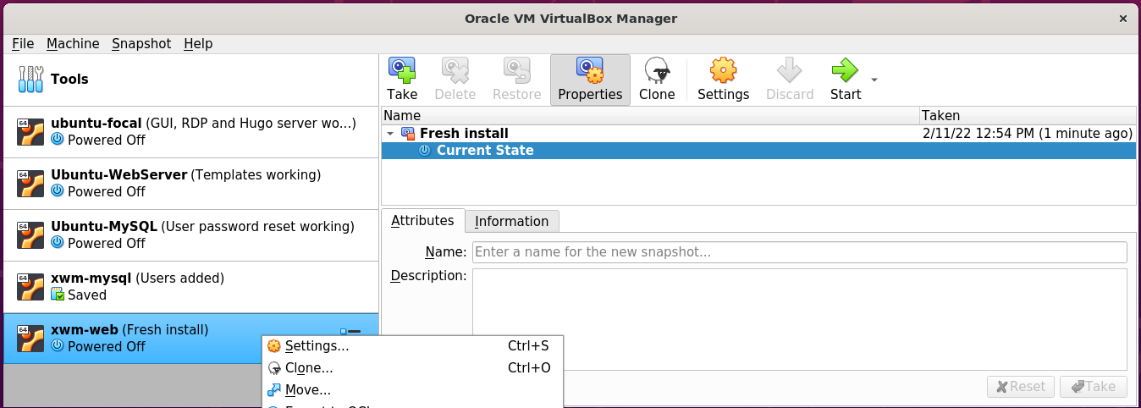

In Setting’s left menu

select Network

Set ‘Attached to’ to: Bridged-Adapter

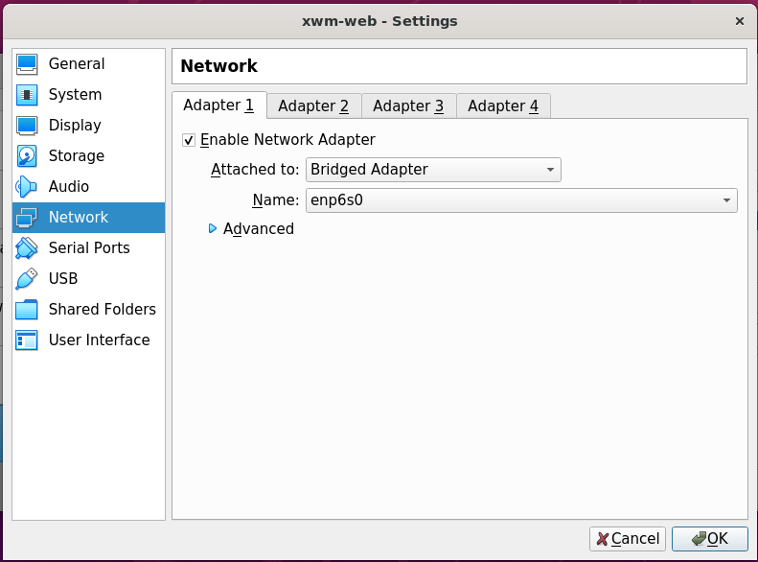

## Install deja-dup and do a backup

https://www.howtoinstall.me/ubuntu/18-04/deja-dup/

Start he virtual machine xwm-web

and terminal, run the following command:

sudo apt update

sudo apt install deja-dup

#### Example – Install deja dup

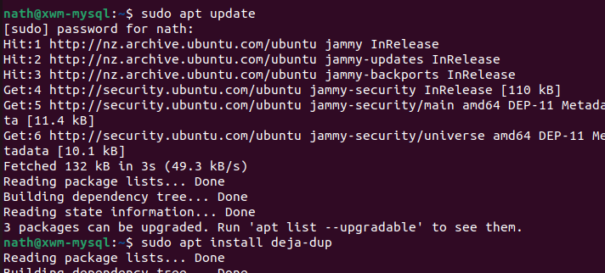

Once installed search for Backup

from Ubuntu’s Show Applications *(Start)* menu.

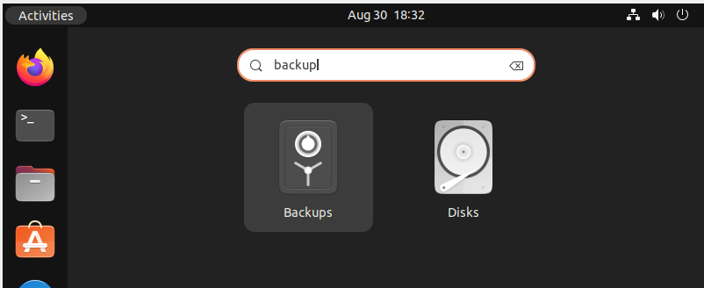

Click Create My First Backup

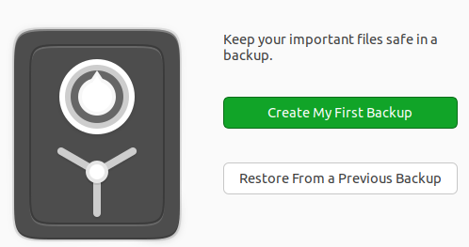

For the meantime, leave the default setting of my home folder: Home(nath)

as folders to be backed up.

In the future I will also need to back up the MySQL folders.

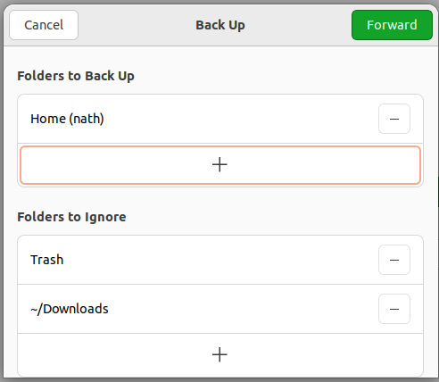

*Next, Select the storage location …*

Save backups to the USB drive

connected to the host machine Ubuntu-LAMP

Storage Location: Network Server

Network Location: smb://ubuntu-lamp.local/vm_backups

Folder: xwm-web

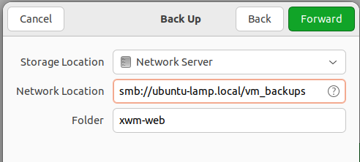

Authenticate as the user nath

on Ubuntu-LAMP

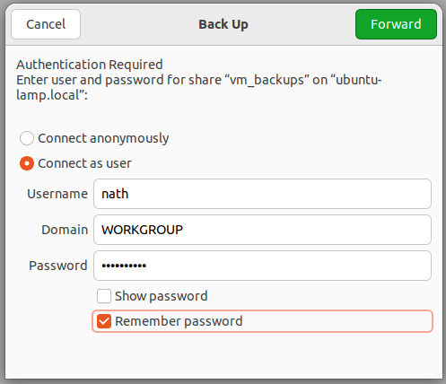

Create the password for the backup

for the virtual machine xwm-web

and select Remember password

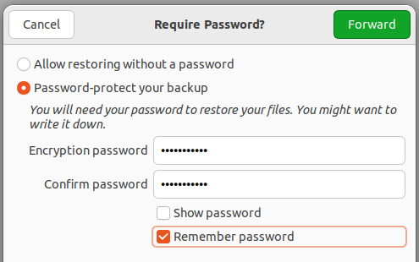

Once the backup completes

select Back up automatically

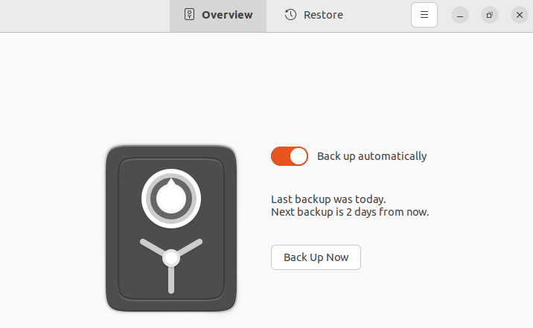

Take a snapshot of the virtual machine

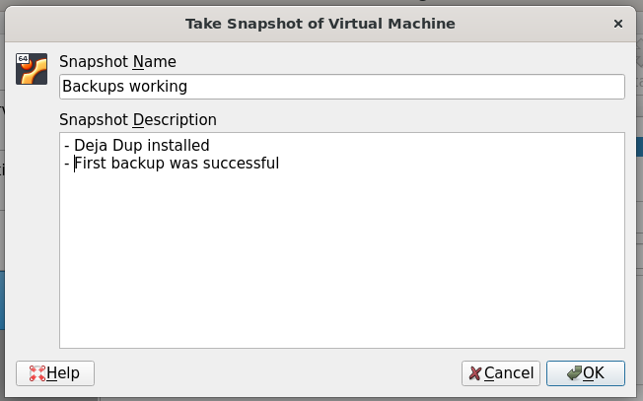

## Remote desktop using xRDP

Install xRDP *(and ‘snake oil’)*

then restart the server

sudo apt update

sudo apt -y install xrdp

sudo adduser xrdp ssl-cert

sudo systemctl restart xrdp

#### Example – install xRDP

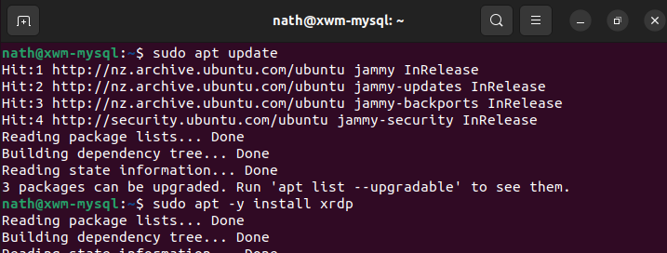

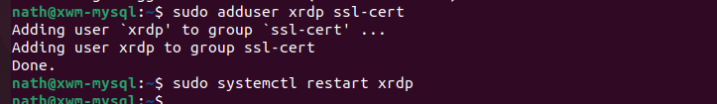

### Configure the firewall for RDP

To allow RDP connections, run the command:

sudo ufw allow 3389

sudo ufw enable

sudo ufw status

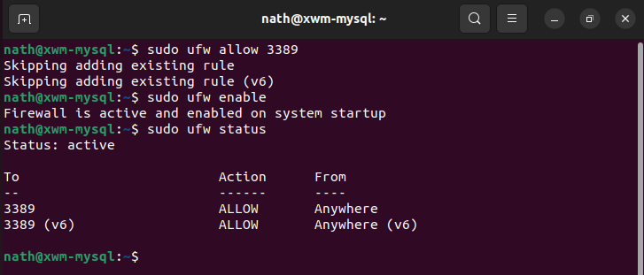

To allow the settings to refresh, restart xwm-web

*Next, Remote onto xwm-mysql …*

## Remote onto xwm-mysql

From Naths-Legion

Remote-desktop onto xwm-mysql

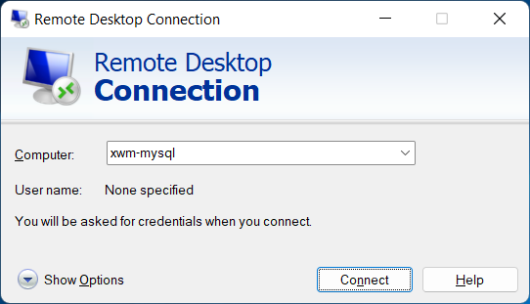

After accepting the connection certificate

xwm-web can be logged on to using remote desktop

from other devices *(eg Naths-Legion)*

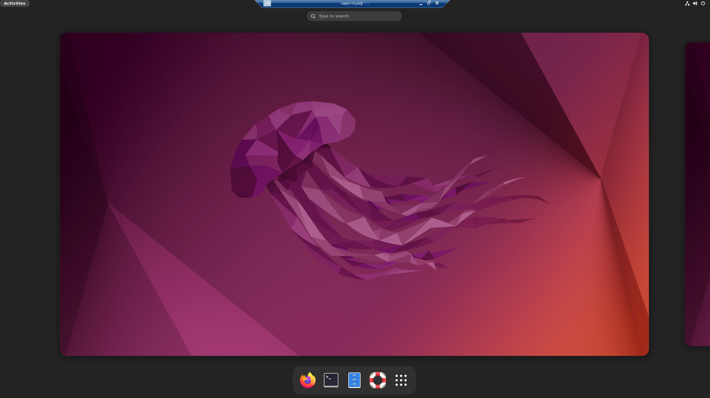

Create a snapshot and backup xwm-web

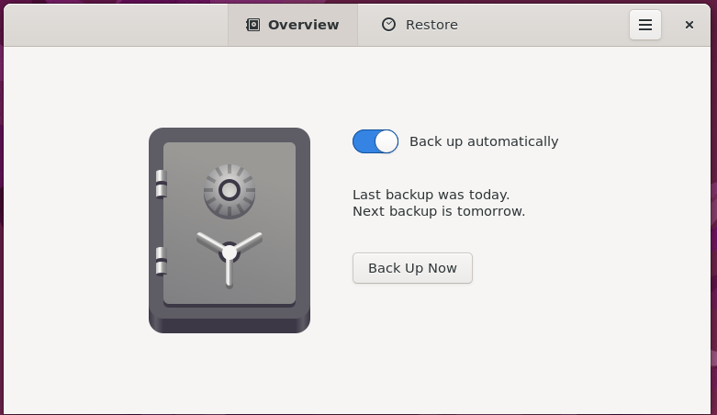

# Install Apache

## Overview

Apache is an open-source web server

that’s available for Linux servers free of charge.

The following goes through the steps

to set up the Apache server.

## Install Apache

To install Apache, install the latest meta-package apache2

by running:

sudo apt update

sudo apt install apache2

After letting the command run

all of the required packages are installed

Test it, by typing in the IP address for the web server

into a web browser.

IP: 192.168.178.48 *(for the virtual machine* ***xwm-web****)*

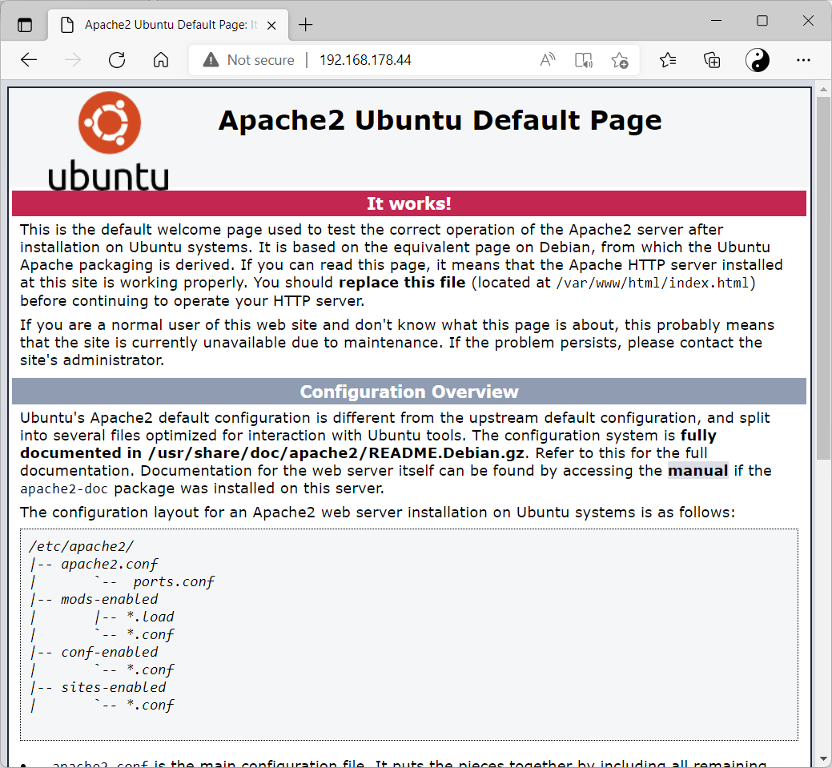

If you see this page

it means Apache has been successfully installed.

### Setting Up Virtual Hosts

When using the Apache2 web server

you can use ***virtual hosts*** to encapsulate configuration details

and host more than one domain from a single server.

We will set up a domain called: xwm-web

Instead of modifying **/var/www/html**,

create a directory structure within /var/www for the nathsweb site,

leaving /var/www/html in place as the default directory

to be served if a client request doesn’t match any other sites.

Create the directory for xwm-web as follows:

sudo mkdir /var/www/*your_domain*

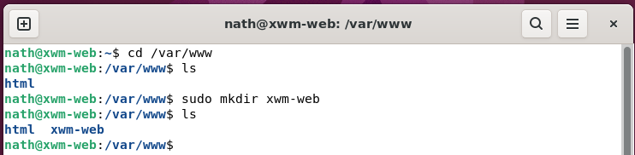

Next, assign ownership of the directory

with the $USER environment variable

sudo chown -R $USER:$USER /var/www/*sitename*

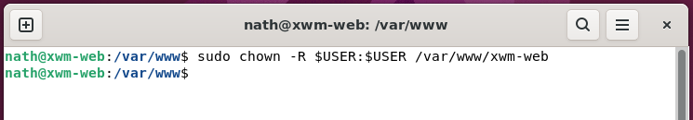

The permissions of your web roots should be correct if you haven’t modified your umask value,

which sets default file permissions.

To ensure that your permissions are correct

and allow the owner to read, write, and execute the files

while granting only read and execute permissions to groups and others,

you can run the following command:

sudo chmod -R 755 /var/www/*sitename*

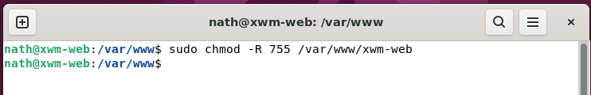

Next, create a sample index.html page

using Nano

sudo nano /var/www/your_domain/index.html

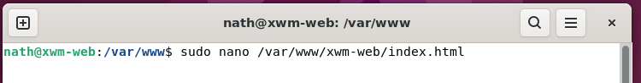

Add the following sample HTML

<html>

<head>

<title>Welcome to nathsweb</title>

</head>

<body>

<h1>Success! The nathsweb domain virtual host is working!</h1>

</body>

</html>

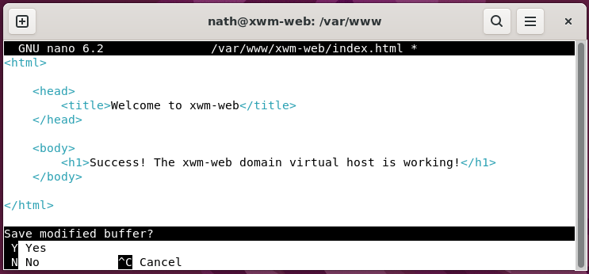

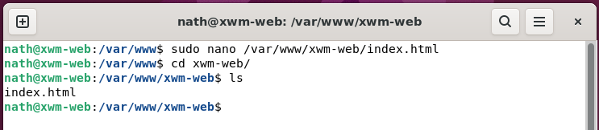

*Next, edit the virtual host file …*

In order for Apache to serve this content,

it’s necessary to create a virtual host file

with the correct directives.

Instead of modifying the default configuration file

located at **/etc/apache2/sites-available/000-default.conf**,

make a new one at **/etc/apache2/sites-available/xwm-web**

sudo nano /etc/apache2/sites-available/xwm-web.conf

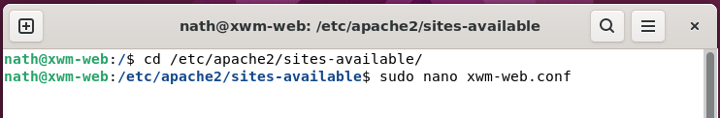

Copy the following configuration block, which is similar to the default,

but updated for our new directory and domain name.

<VirtualHost *:80>

ServerAdmin NathsLAMP@hotmail.com

ServerName xwm-web

ServerAlias www.xwm-web

DocumentRoot /var/www/xwm-web

ErrorLog ${APACHE_LOG_DIR}/error.log

CustomLog ${APACHE_LOG_DIR}/access.log combined

</VirtualHost>

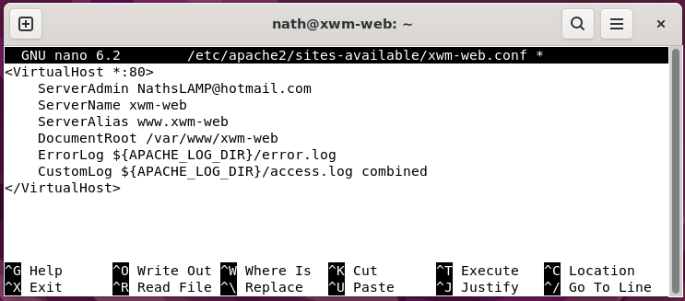

Notice that we’ve updated the **DocumentRoot** to our new directory

and updated **ServerAdmin** to an email that the xwm-web site administrator can access.

We’ve also added two directives:

**ServerName** which establishes the base domain

that should match for this virtual host definition.

**ServerAlias** which defines further names

that should match as if they were the base name.

Enable the file with the tool a2ensite

sudo a2ensite xwm-web.conf

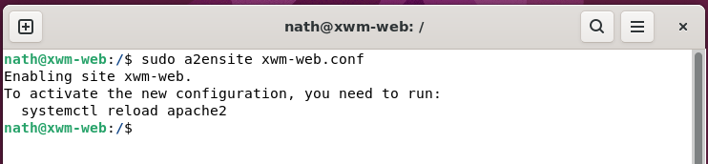

Restart Apache to implement your changes:

sudo systemctl restart apache2

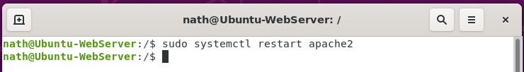

## Test the site

1. Restart the server
2. Clear the Firefox browser cache by clicking:

Settings > Privacy & Security > Cookies & Site Data > Clear Data

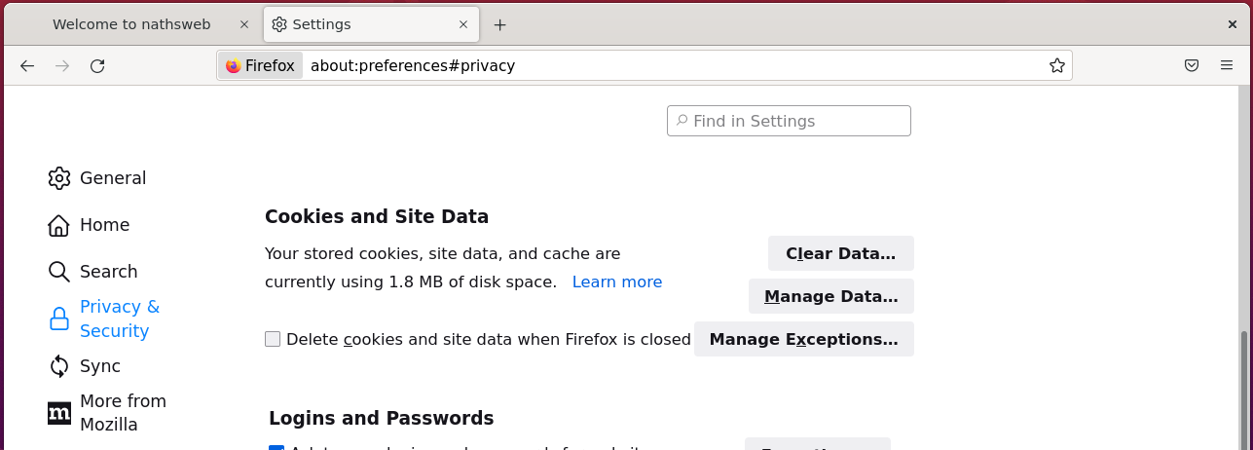

1. The following will display the website

URL: <http://xwm-web>

#### Test – xwm-web is displayed on local web browser

Test from xwm-web - okay

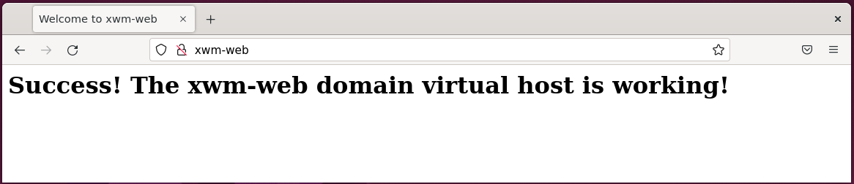

Using the IP address will also work from other devices on the same subnet

providing the firewall has been configured

to allow http data.

Configure the firewall to allow http and https.

sudo ufw allow http

sudo ufw allow https

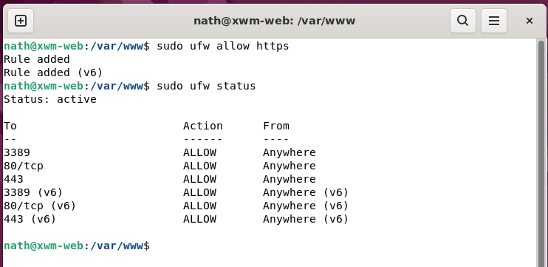

#### Test – xwm-web is displayed on another device’s web browser

Test from Naths-Legion - okay

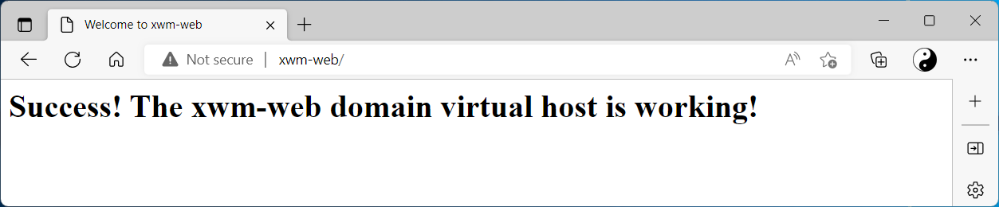

Take a snap shot and backup the virtual machine xwm-web

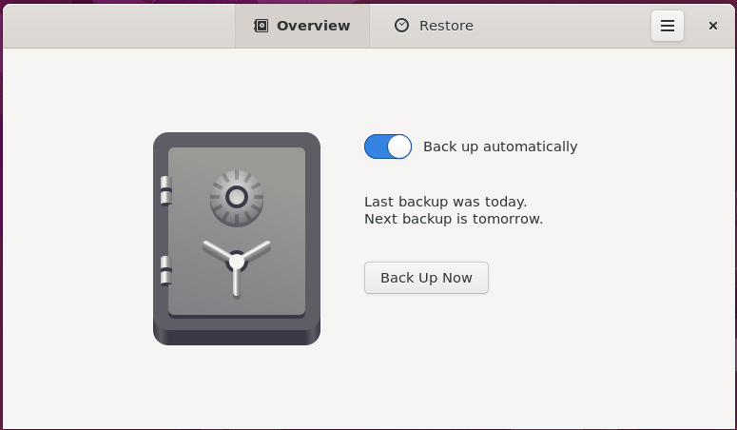

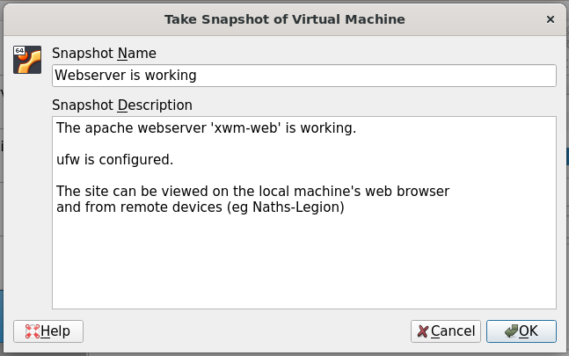

## Install Visual Studio code

To install Visual Studio Code

run the following command

sudo snap install code --classic

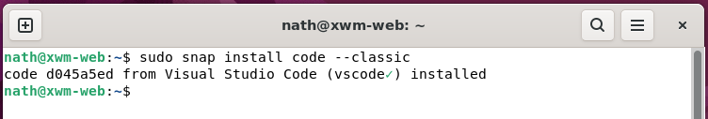

Once installed Visual Studio Code can be run from the start menu

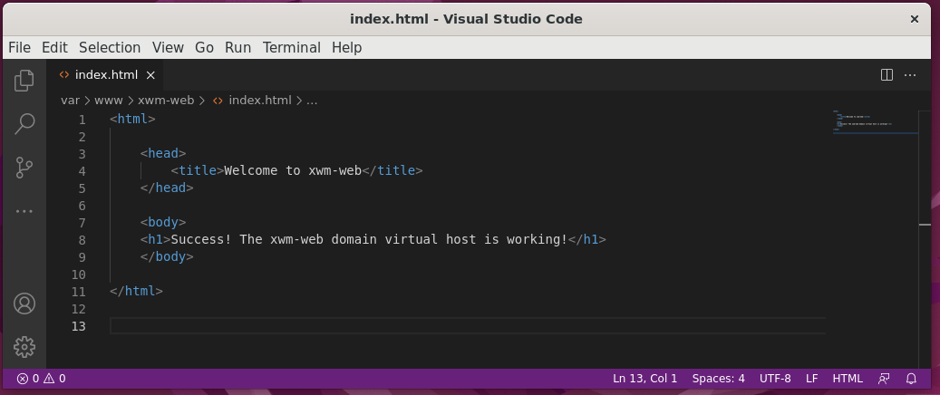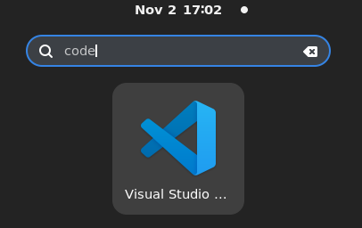

Take a snap shot and backup the virtual machine xwm-web



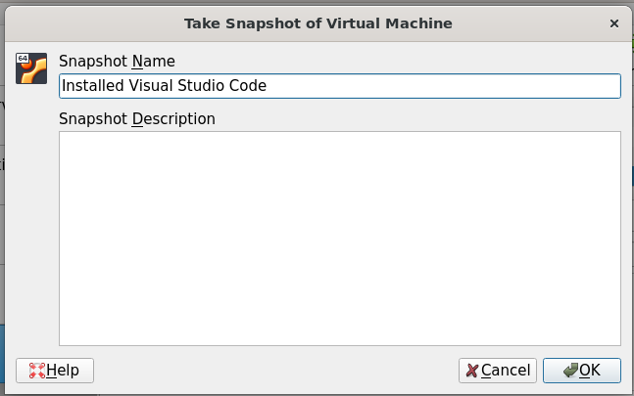

# Install MySQL

Although MySQL will not be running on xwm-web

it’s really handy to have it installed

so remote tests to the MySQL server can be conducted.

When new code that communicates with the MySQL server xwm-mysql

is being developed, it’s important to know if issues are:

* code bugs
* a network issue
* a problem on the MySQL server

## Install MySQL on xwm-web

To install MySQL run the following command

sudo apt update

sudo apt install mysql-server

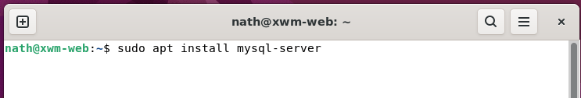

Check MySQL’s status, by running the command

sudo service mysql status

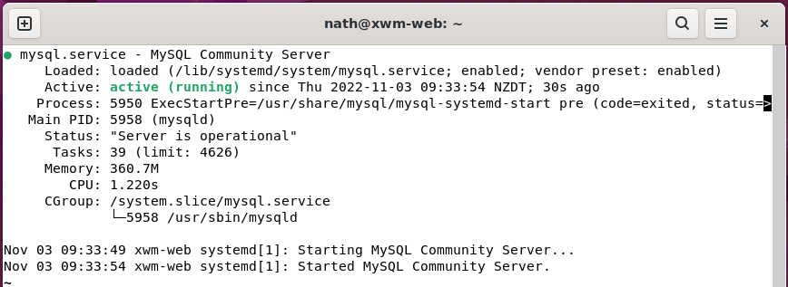

If the MySQL server is not running correctly

the following command will restart it:

sudo service mysql restart

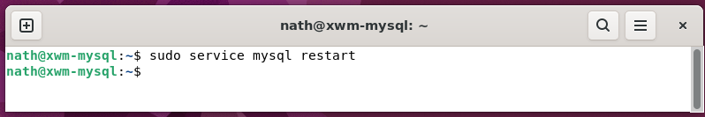

*Next, Connect to a remote MySQL server …*

## Connect to a remote MySQL server

Now MySQL server has been installed on the web server xwm-web

connect to the remote MySQL server xwm-mysql

using the following command

mysql -h xwm-mysql -u admin -p

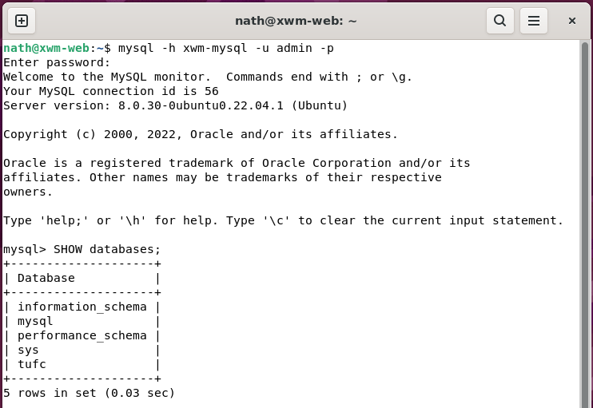

#### Create a snapshot and backup xwm-web

